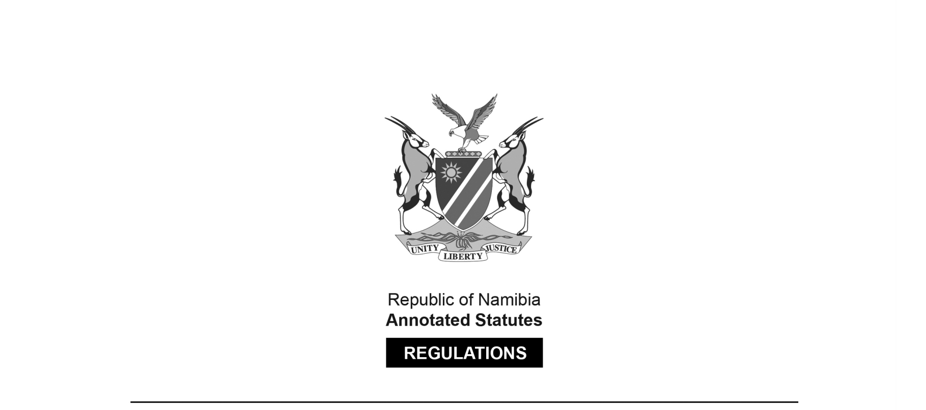

REGULATIONS MADE IN TERMS OF

Agricultural Produce Export  
Ordinance 13 of 1928

section 6

Regulations governing Packing and  
Marking of Wool and Karakul Hair

Government Notice 146 of 1942

([OG 985](http://www.lac.org.na/laws/1942/og985.pdf))

came into force on date of publication: 1 August 1942

Note that regulation 10 repeals the regulations published in GN 125/1935 ([OG 624](http://www.lac.org.na/laws/1935/og624.pdf)), as amended by GN 14/1936 ([OG 653](http://www.lac.org.na/laws/1936/og653.pdf)) and GN 138/1936 ([OG 683](http://www.lac.org.na/laws/1936/og683.pdf)), and the regulations in GN 172/1936 ([OG 688](http://www.lac.org.na/laws/1936/og688.pdf)),   
as amended by GN 69/1938 ([OG 749](http://www.lac.org.na/laws/1939/og749.pdf)).

ARRANGEMENT OF REGULATIONS

[The individual regulations do not have headings.]

**1.** Wool or karakul hair shall be packed either in bales or jute packs known as 11¼, lb. packs (nominal) which have not been used previously or in grain bags.

**2.** Every bale or bag of wool or karakul hair (other than a bale or bag containing scoured wool or karakul hair) shall be securely fastened, either with blue-dyed sewing twine or metal clips, and only blue-dyed sewing twine shall be used for repairing holes in any such bale or bag.

**3.** (1) Shankings, matted brisket skirts and wool or karakul hair defiled by urine, dung, excessive sweat or grease shall be removed from other wool or karakul hair and packed separately and the container thereof shall be clearly marked “LOX”.

(2) Wool or karakul hair contaminated by paint or other branding material shall be removed from other wool or karakul hair and packed separately and the container thereof shall be clearly marked “BRANDS”.

**4.** All bellies, pieces and skirts shall be removed from all other wool or karakul hair and shall be packed separately. The container shall be marked “C.B.P.”, if the average length of the contents is one and three-quarter inches or over, and “B.P.” if the average length is below one and three-quarter inches. (By pieces and skirts is meant all the short extremities of fleeces, excluding LOX.)

[There should be a space in between the words “the” and “contents”.]

**5.** (1) Every bale or bag of wool or karakul hair containing wool or karakul hair which has been plucked, shorn or otherwise removed from dead animals shall be clearly marked “PLK”.

(2) Every bale or bag of wool or karakul hair containing wool or karakul hair which has been shorn from skins of slaughtered animals shall be clearly marked “VEL”.

**6.** (1) Every bale or bag of wool or karakul hair shall be clearly marked with the name or registered trade mark or registered mark or registered cattle-brand of the owner thereof, and his address or the name of the railway station from which the wool or karakul hair was railed.

(2) If any person has acquired from any other person, wool or karakul hair in a container bearing the name and address of that other person, such name and address of the firstmentioned person shall be added.

(3) Any wool or karakul hair which has been repacked must be clearly marked “REPACKS” and the repacker’s name and address must appear on the bale.

**7.** All markings on bales or bags in terms of these regulations shall consist of letters not less than one and a half inches in height, and shall be placed together on the end in the case of bales, and on the side in the case of bags.

**8.** Wool or karakul hair intended for sale shall be subject to inspection by an inspector designated by the Senior Veterinary Officer of the Administration.

**9.** An inspector mentioned in regulation 8 may at all reasonable times enter any premises in which there is any wool or karakul hair or in which the inspector has reason to believe there is any wool or karakul hair and may examine any part of the premises and any bale or bag of wool or karakul hair therein, and may for the purpose of examining the wool or karakul hair open any such bale or bag.

**10.** The regulations published under Government Notice No. 125 of 1935 as amended by Government Notices Nos. 14 of 1936 and 138 of 1936, and Government Notice No. 172 of 1936 as amended by Government Notice No. 69 of 1938 are hereby repealed.

(*Note:* Failure to comply with the provisions of these regulations is an offence under section *seven* of Ordinance No. 13 of 1928 punishable by a fine not exceeding £100.)